22.1: a)
b) As long as the sheet is flat, its shape does not matter.
ci) The maximum flux occurs at an angle 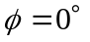between the normal and field.
cii) The minimum flux occurs at an angle 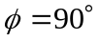 between the normal and field.
In part i), the paper is oriented to “capture” the most field lines whereas in ii) the area is oriented so that it “captures” no field lines.

